Lab - Troubleshooting ACL Configuration and Placement

1. Topology

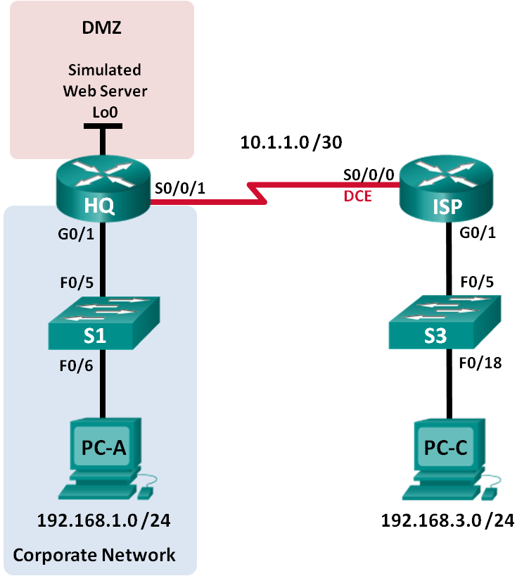

1. Addressing Table

|  |  |  |  |  |
| --- | --- | --- | --- | --- |
| Device | Interface | IP Address | Subnet Mask | Default Gateway |
| HQ | G0/1 | 192.168.1.1 | 255.255.255.0 | N/A |
|  | S0/0/1 | 10.1.1.2 | 255.255.255.252 | N/A |
|  | Lo0 | 192.168.4.1 | 255.255.255.0 | N/A |
| ISP | G0/1 | 192.168.3.1 | 255.255.255.0 | N/A |
|  | S0/0/0 (DCE) | 10.1.1.1 | 255.255.255.252 | N/A |
| S1 | VLAN 1 | 192.168.1.11 | 255.255.255.0 | 192.168.1.1 |
| S3 | VLAN 1 | 192.168.3.11 | 255.255.255.0 | 192.168.3.1 |
| PC-A | NIC | 192.168.1.3 | 255.255.255.0 | 192.168.1.1 |
| PC-C | NIC | 192.168.3.3 | 255.255.255.0 | 192.168.3.1 |

1. Objectives

Part 1: Build the Network and Configure Basic Device Settings

Part 2: Troubleshoot Internal Access

Part 3: Troubleshoot Remote Access

1. Background / Scenario

An access control list (ACL) is a series of IOS commands that can provide basic traffic filtering on a Cisco router. ACLs are used to select the types of traffic to be processed. A single ACL statement is called and access control entry (ACE). The ACEs in the ACL are evaluated from top to bottom with an implicit deny all ACE at the end of the list. ACLs can also control the types of traffic into or out of a network by the source and destination hosts or network. To process the desired traffic correctly, the placement of the ACLs is critical.

In this lab, a small company has just added a web server to the network to allow customers to access confidential information. The company network is divided into two zones: Corporate network zone and Demilitarized Zone (DMZ). The corporate network zone houses private servers and internal clients. The DMZ houses the externally accessible web server (simulated by Lo0 on HQ). Because the company can only administer its own HQ router, all ACLs must be applied to the HQ router.

* ACL 101 is implemented to limit the traffic out of the corporate network zone. This zone houses the private servers and internal clients (192.168.1.0/24). No other network should be able to access it.
* ACL 102 is used to limit the traffic into the corporate network. Only responses to requests that originated from within the corporate network are allowed back into that network. This includes TCP-based requests from internal hosts such as Web and FTP. ICMP is allowed into the network for troubleshooting purposes so that incoming ICMP messages generated in response to pings can be received by internal hosts.
* ACL 121 controls outside traffic to the DMZ and corporate network. Only HTTP traffic is allowed to the DMZ web server (simulated by Lo0 on R1). Other network related traffic, such as EIGRP, is allowed from outside networks. Furthermore, valid internal private addresses, such as 192.168.1.0, loopback address such as 127.0.0.0 and multicast addresses are denied entrance to the corporate network to prevent malicious network attacks from outside users.

**Note**: The routers used with CCNA hands-on labs are Cisco 1941 Integrated Services Routers (ISRs) with Cisco IOS Release 15.2(4)M3 (universalk9 image). The switches used are Cisco Catalyst 2960s with Cisco IOS Release 15.0(2) (lanbasek9 image). Other routers, switches and Cisco IOS versions can be used. Depending on the model and Cisco IOS version, the commands available and output produced might vary from what is shown in the labs. Refer to the Router Interface Summary Table at the end of the lab for the correct interface identifiers.

**Note**: Make sure that the routers and switches have been erased and have no startup configurations. If you are unsure, contact your instructor.

1. Required Resources

* 2 Routers (Cisco 1941 with Cisco IOS Release 15.2(4)M3 universal image or comparable)
* 2 Switches (Cisco 2960 with Cisco IOS Release 15.0(2) lanbasek9 image or comparable)
* 2 PCs (Windows 7, Vista, or XP with terminal emulation program, such as Tera Term)
* Console cables to configure the Cisco IOS devices via the console ports
* Ethernet and serial cables as shown in the topology

1. Build the Network and Configure Basic Device Settings

In Part 1, you set up the network topology and configure the routers and switches with some basic settings, such as passwords and IP addresses. Preset configurations are also provided for you for the initial router configurations. You will also configure the IP settings for the PCs in the topology.

* 1. Cable the network as shown in the topology.
  2. Configure PC hosts.
  3. Initialize and reload the routers and switches as necessary.
  4. (Optional) Configure basic settings for each switch.
     1. Disable DNS lookup.
     2. Configure host names as shown in the Topology.
     3. Configure IP address and default gateway in Addressing Table.
     4. Assign **cisco** as the console and vty passwords.
     5. Assign **class** as the privileged EXEC password.
     6. Configure **logging synchronous** to prevent console messages from interrupting command entry.
  5. Configure basic settings for each router. - pominąłem bo w każdej labie to było
     1. Disable DNS lookup.
     2. Configure host names as shown in the topology.
     3. Assign **cisco** as the console and vty passwords.
     4. Assign **class** as the privileged EXEC password.
     5. Configure **logging synchronous** to prevent console messages from interrupting command entry.
  6. Configure HTTP access and user credentials on HQ router. - nie działa w packet tracer

Local user credentials are configured to access the simulated web server (192.168.4.1).

HQ(config)# **ip http server**

HQ(config)# **username admin privilege 15 secret adminpass**

HQ(config)# **ip http authentication local**

* 1. Load router configurations.

The configurations for the routers ISP and HQ are provided for you. There are errors within these configurations, and it is your job to determine the incorrect configurations and correct them.

Router ISP

hostname ISP

interface GigabitEthernet0/1

ip address 192.168.3.1 255.255.255.0

no shutdown

interface Serial0/0/0

ip address 10.1.1.1 255.255.255.252

clock rate 128000

no shutdown

router eigrp 1

network 10.1.1.0 0.0.0.3

network 192.168.3.0

no auto-summary

end

Router HQ

hostname HQ

interface Loopback0

ip address 192.168.4.1 255.255.255.0

interface GigabitEthernet0/1

ip address 192.168.1.1 255.255.255.0

ip access-group 101 out

ip access-group 102 in

no shutdown

interface Serial0/0/1

ip address 10.1.1.2 255.255.255.252

ip access-group 121 in

no shutdown

router eigrp 1

network 10.1.1.0 0.0.0.3

network 192.168.1.0

network 192.168.4.0

no auto-summary

access-list 101 permit ip 192.168.11.0 0.0.0.255 any

access-list 101 deny ip any any

access-list 102 permit tcp any any established

access-list 102 permit icmp any any echo-reply

access-list 102 permit icmp any any unreachable

access-list 102 deny ip any any

access-list 121 permit tcp any host 192.168.4.1 eq 89

access-list 121 deny icmp any host 192.168.4.11

access-list 121 deny ip 192.168.1.0 0.0.0.255 any

access-list 121 deny ip 127.0.0.0 0.255.255.255 any

access-list 121 deny ip 224.0.0.0 31.255.255.255 any

access-list 121 permit ip any any

access-list 121 deny ip any any

end

1. Troubleshoot Internal Access

In Part 2, the ACLs on router HQ are examined to determine if they are configured correctly.

* 1. Troubleshoot ACL 101

ACL 101 is implemented to limit the traffic out of the corporate network zone. This zone houses only internal clients and private servers. Only 192.168.1.0/24 network can exit this corporate network zone.

* + 1. Can PC-A ping its default gateway? ____NIE_______
    2. After verifying that the PC-A was configured correctly, examine the HQ router to find possible configuration errors by viewing the summary of ACL 101. Enter the command **show access-lists 101**.

HQ# **show access-lists 101**

Extended IP access list 101

10 permit ip 192.168.11.0 0.0.0.255 any

20 deny ip any any

* + 1. Are there any problems with ACL 101?

___Tak jest zły permit powinno być 192.168.1.0 zamiast 192.168.11.0___

* + 1. Examine the default gateway interface for the 192.168.1.0 /24 network. Verify that the ACL 101 is applied in the correct direction on the G0/1 interface. Enter the **show ip interface g0/1** command.

HQ# **show ip interface g0/1**

GigabitEthernet0/1 is up, line protocol is up

Internet address is 192.168.1.1/24

Broadcast address is 255.255.255.255

Address determined by setup command

MTU is 1500 bytes

Helper address is not set

Directed broadcast forwarding is disabled

Multicast reserved groups joined: 224.0.0.10

Outgoing access list is 101

Inbound access list is 102

Is the direction for interface G0/1 configured correctly for ACL 101?

_____Nie ACL 101 powinien być in zamiast out__________________________

* + 1. Correct the errors found regarding ACL 101 and verify the traffic from network 192.168.1.0 /24 can exit the corporate network. Record the commands used to correct the errors.

conf t → int g0/1 → no ip access-group 101 out → ip access-group 101 in → end ____________________________________________________

____________________________________________________________________________________

____________________________________________________________________________________

____________________________________________________________________________________

____________________________________________________________________________________

* + 1. Verify PC-A can ping its default gateway interface.
  1. Troubleshoot ACL 102

ACL 102 is implemented to limit traffic into the corporate network. Traffic originating from the outside network is not allowed onto the corporate network. Remote traffic is allowed into the corporate network if the established traffic originated from the internal network. ICMP reply messages are allowed for troubleshooting purposes.

* + 1. Can PC-A ping PC-C? __Może ______
    2. Examine the HQ router to find possible configuration errors by viewing the summary of ACL 102. Enter the command **show access-lists 102**.

HQ# **show access-lists 102**

Extended IP access list 102

10 permit tcp any any established

20 permit icmp any any echo-reply

30 permit icmp any any unreachable

40 deny ip any any (57 matches)

* + 1. Are there any problems with ACL 102?

_______Nie ma problemów______________________________________________________

* + 1. Verify that the ACL 102 is applied in the correct direction on G0/1 interface. Enter the **show ip interface g0/1** command.

HQ# **show ip interface g0/1**

GigabitEthernet0/1 is up, line protocol is up

Internet address is 192.168.1.1/24

Broadcast address is 255.255.255.255

Address determined by setup command

MTU is 1500 bytes

Helper address is not set

Directed broadcast forwarding is disabled

Multicast reserved groups joined: 224.0.0.10

Outgoing access list is 101

Inbound access list is 101

* + 1. Are there any problems with the application of ACL 102 to interface G0/1?

__Tak 102 brakuje kierunku out w interface g0/1___

* + 1. Correct any errors found regarding ACL 102. Record the commands used to correct the errors.

__conf t → int g0/1 → ip access-group 102 out → end___

_____________________________________________________________________________

* + 1. Can PC-A ping PC-C now? ___Tak____

1. Troubleshoot Remote Access

In Part 3, ACL 121 is configured to prevent spoofing attacks from the outside networks and allow only remote HTTP access to the web server (192.168.4.1) in DMZ.

* + 1. Verify ACL 121 has been configured correctly. Enter the **show ip access-list 121** command.

HQ# **show ip access-lists 121**

Extended IP access list 121

10 permit tcp any host 192.168.4.1 eq 89

20 deny icmp any host 192.168.4.11

30 deny ip 192.168.1.0 0.0.0.255 any

40 deny ip 127.0.0.0 0.255.255.255 any

50 deny ip 224.0.0.0 31.255.255.255 any

60 permit ip any any (354 matches)

70 deny ip any any

Are there any problems with this ACL?

___Tak błędy są w liniach 10 i 20, zamiast eq 89 powinno byc eq 80, zamiast any host 192.168.4.11 powinno byc 192.168.4.1 __________________________________________________________________________

* + 1. Verify that the ACL 121 is applied in the correct direction on the R1 S0/0/1 interface. Enter the **show ip interface s0/0/1** command.

HQ# **show ip interface s0/0/1**

Serial0/0/1 is up, line protocol is up

Internet address is 10.1.1.2/30

Broadcast address is 255.255.255.255

<output omitted>

Multicast reserved groups joined: 224.0.0.10

Outgoing access list is not set

Inbound access list is 121

Are there any problems with the application of this ACL?

___W moim nie ma Multicast reserved groups joined_____________________________________

____________________________________________________________________________________

* + 1. If any errors were found, make and record the necessary configuration changes to ACL 121.

___conf t → ip access-list extended 121 → no 10 permit tcp any host 192.168.4.1 eq 89 → 10 permit tcp any host 192.168.4.1 eq 80 → end _____________

____conf t → ip access-list extended 121 → no 20 deny icmp any host 192.168.4.11 → 20 deny icmp any host 192.168..4.1 → end __________________________________________________

____________________________________________________________________________________

____________________________________________________________________________________

____________________________________________________________________________________

____________________________________________________________________________________

* + 1. Verify that PC-C can only access the simulated web server on HQ by using the web browser. Provide the username **admin** and password **adminpass** to access the web server (192.168.4.1).

1. Reflection
   1. How should the ACL statement be ordered? From general to specific or vice versa?

__Kolejność powinna być ze specific do general ponieważ ACL jest wykonywany od góry do dołu w kolejności sekwencyjnej. Jeżeli warunek jest true to procesowanie listy jest zatrzymywane (nie patrzy dalej)____

* 1. If you delete an ACL by using the **no access-list** command and the ACL is still applied to the interface, what happens? ___Zostanie zastosowany domyślny deny, powinniśmy uważać gdy usuwamy ACL zaaplikowany do aktywnego interfejsu_______

1. Router Interface Summary Table

|  |  |  |  |  |
| --- | --- | --- | --- | --- |
| Router Interface Summary | | | | |
| Router Model | Ethernet Interface #1 | Ethernet Interface #2 | Serial Interface #1 | Serial Interface #2 |
| 1800 | Fast Ethernet 0/0 (F0/0) | Fast Ethernet 0/1 (F0/1) | Serial 0/0/0 (S0/0/0) | Serial 0/0/1 (S0/0/1) |
| 1900 | Gigabit Ethernet 0/0 (G0/0) | Gigabit Ethernet 0/1 (G0/1) | Serial 0/0/0 (S0/0/0) | Serial 0/0/1 (S0/0/1) |
| 2801 | Fast Ethernet 0/0 (F0/0) | Fast Ethernet 0/1 (F0/1) | Serial 0/1/0 (S0/1/0) | Serial 0/1/1 (S0/1/1) |
| 2811 | Fast Ethernet 0/0 (F0/0) | Fast Ethernet 0/1 (F0/1) | Serial 0/0/0 (S0/0/0) | Serial 0/0/1 (S0/0/1) |
| 2900 | Gigabit Ethernet 0/0 (G0/0) | Gigabit Ethernet 0/1 (G0/1) | Serial 0/0/0 (S0/0/0) | Serial 0/0/1 (S0/0/1) |
| **Note**: To find out how the router is configured, look at the interfaces to identify the type of router and how many interfaces the router has. There is no way to effectively list all the combinations of configurations for each router class. This table includes identifiers for the possible combinations of Ethernet and Serial interfaces in the device. The table does not include any other type of interface, even though a specific router may contain one. An example of this might be an ISDN BRI interface. The string in parenthesis is the legal abbreviation that can be used in Cisco IOS commands to represent the interface. | | | | |